**Transfer Learning using ResNet50V2**

**Transfer Learning** is a machine learning technique where a model that has been trained on one task is reused on a new, but related task. In the case of using **ResNet50V2**, a pre-trained Convolutional Neural Network (CNN), for a task like image classification, the process involves leveraging the learned features from the ImageNet dataset to help classify new images in a task-specific domain, like breast cancer detection.

**ResNet50V2:**

* **ResNet** stands for **Residual Networks**, a type of deep neural network architecture that is specifically designed to overcome the problem of vanishing gradients in very deep networks.
* **ResNet50V2** is a variant of ResNet that consists of 50 layers. It was trained on the **ImageNet** dataset, which contains millions of images categorized into 1,000 classes.
* The **V2** stands for the second version, which introduces **pre-activation** in the residual blocks, improving training stability and performance.

**How Transfer Learning Works with ResNet50V2:**

1. **Pre-trained Model**:
   * The ResNet50V2 model is initially trained on ImageNet. This model has learned low-level features (edges, corners) and high-level features (shapes, textures) from a wide variety of images.
2. **Feature Extraction**:
   * When we use ResNet50V2 for a new task, such as breast cancer detection, the lower layers of the network (which learn simple patterns) are **frozen**. This means these layers will not be updated during the training of the new model.
   * The **higher layers** of the network are adjusted (fine-tuned) to classify images based on the new task.
3. **Fine-Tuning**:
   * In the fine-tuning process, the model is modified to learn specific features relevant to the new dataset. For example, in breast cancer detection, the model might learn specific patterns related to benign and malignant tumor cells.
4. **Building the Final Model**:
   * After freezing most of the ResNet layers, new layers (e.g., **Global Average Pooling** and **Dense layers**) are added to classify the new data (like distinguishing between "cancer" and "no cancer").
   * The **Dense layer** with a sigmoid activation function gives a probability score (0 to 1) that indicates the likelihood of the image belonging to a certain class.

**CNN (Convolutional Neural Network) Overview**

A **CNN** is a type of deep learning algorithm specifically designed for processing structured grid data, like images. Here's a breakdown of the key components:

**Components of CNNs:**

1. **Convolutional Layer**:
   * The core building block of a CNN. It applies convolution operations on the image to detect patterns such as edges, corners, and textures. Filters or kernels are learned during training.
2. **Pooling Layer**:
   * Reduces the spatial dimensions (width and height) of the feature maps, which helps in reducing computational load and overfitting. Common pooling types are **Max Pooling** and **Average Pooling**.
3. **Fully Connected (Dense) Layer**:
   * After the convolution and pooling layers, the features are flattened and passed through fully connected layers for final classification or regression tasks.
4. **Activation Functions**:
   * Functions like **ReLU (Rectified Linear Unit)** are applied after each convolution operation to introduce non-linearity, enabling the network to learn complex patterns.
5. **Dropout and Batch Normalization**:
   * **Dropout** helps to reduce overfitting by randomly turning off some neurons during training.
   * **Batch Normalization** ensures that the data is normalized across each mini-batch, which speeds up training and provides regularization.

**Why CNNs Work Well for Image Data:**

* CNNs are particularly suited for image processing because they can automatically learn hierarchical patterns from raw image pixels. The network begins by learning simple patterns and progresses to more complex ones as the layers deepen.
* Unlike traditional neural networks, CNNs do not require manual feature extraction, which makes them highly effective for image classification tasks.

**SVM (Support Vector Machine) Overview**

**SVM** is a supervised machine learning algorithm used for classification and regression tasks. It is particularly powerful in high-dimensional spaces, and it works by finding the optimal hyperplane that best separates different classes in the feature space.

**Key Concepts in SVM:**

1. **Hyperplane**:
   * In 2D, a hyperplane is a line that separates data points of different classes. In higher dimensions, it's a plane or a more complex structure.
   * The goal of SVM is to find the hyperplane that maximizes the margin between the two classes.
2. **Support Vectors**:
   * These are the data points that are closest to the decision boundary (hyperplane). SVM uses these support vectors to define the hyperplane.
3. **Kernel Trick**:
   * SVMs can efficiently perform classification by mapping input data into high-dimensional feature spaces using a **kernel** function. This is useful when the data is not linearly separable in its original space. Common kernels include:
     + **Linear Kernel**
     + **Polynomial Kernel**
     + **Radial Basis Function (RBF) Kernel**
4. **Margin**:
   * The margin is the distance between the hyperplane and the nearest data point from any class. SVM aims to maximize this margin to increase the classifier's generalization capability.

**How SVM Works:**

* In SVM, the algorithm tries to find the best separating hyperplane that divides the data into two categories with the maximum margin.
* If the data is not linearly separable, SVM uses kernels to map the data into higher-dimensional space where a separating hyperplane can be found.

**SVM vs CNN:**

* **SVM** is effective for small to medium-sized datasets and simpler models. It requires feature extraction before training, which can be complex for image data.
* **CNN** is designed to work directly with raw image data, automatically learning features and patterns. It scales better to large datasets and complex tasks.

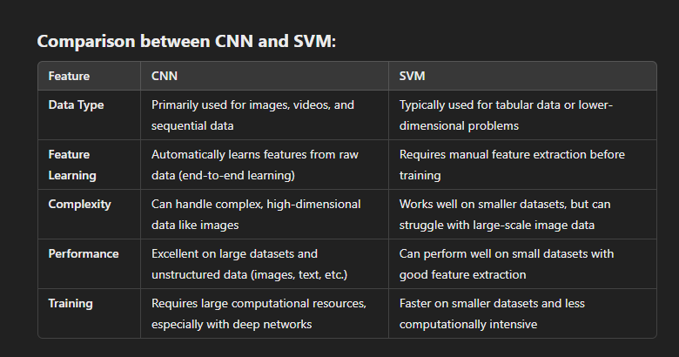

**Summary:**

* **Transfer Learning with ResNet50V2** is a method that allows you to use a pre-trained model (ResNet50V2) for image classification tasks like detecting breast cancer, with minimal changes to the architecture.
* **CNNs** are the preferred choice for image classification as they can learn hierarchical features from raw data automatically.
* **SVM** is a powerful classifier but is more suited to smaller datasets with well-defined features, and it doesn't naturally handle the complexity of image data as CNNs do.

4o mini